Cinema Buddy

This is an app that enhances the entire cinema experience from start to finish for each individual user. Cinema Buddy focuses on the experience itself and assisting its users in gaining the most from going to the cinema.

This app will give the user all of the designated information and knowledge needed to truly understand the movie they are going to see. It will provide all relevant information simply and effectively so that the user can go from essentially no knowledge of the movie to being completely immersed in the world in a matter of minutes.

I expect this app to reach a broad target of users. It is an app where users can swiftly go into it, efficiently access the information for the desired movie and gain a sense of confidence that they know enough information to follow along.

The Key features of the app:

1. Short synopsis of what happens in the movie (similar to IMDB)
2. Knowing how long is left in the movie
3. Any extra scenes in the credits
4. If the movie is a sequel
5. If it is a sequel, where it fits in the franchise (straight after the last film etc.)
6. If the movie is an adaptation of a book/play
7. Prior real-life knowledge (Bohemian Rhapsody)
8. Key Actors
9. Key music

This is not an application for the most die-hard of fan’s for movies, as they already know the ins and outs of the movies franchise and world. This is an app designed for the type of person whose knowledge is ranging from non-existent to knows a few different things. We want to effectively bring these types of people up as close as we can to the knowledge level of the other person. This can be people such as individuals in a friendship group, a boyfriend/girlfriend or an individual/group who want to go to the cinemas but need direction on what to see.

Key ideologies

1. Knowledge
2. Helpful
3. Efficiency
4. Succinctness
5. Usability

Audience

The users can be anyone that has a smartphone. One key demographic to look at is Targeted audiences will include:

* 14 – 18 year old teens
* 18-28 year old friendship groups
* 18-28 romantic partners

Competitors

The app that is closest to this app is RunPee. This is an app entirely dedicated to determining when the best time to go and pee in a movie is. It is a very basic design but can definitely be improved on and made much clearer.

Positives to take away:

* Initial interface is simple and easy to navigate
* Offers best time to take a toilet break (difficult to achieve)
* Has a currency system
* Offers information in the form of links to articles
* Offers if there is anything extra in the credits
* Has a dedicated app website
* Create an account feature
* Offers poll’s for additional user information.

Negatives to note:

* Initial user interface is bland, uninspiring
* Once a movie is chosen, it is difficult to see where the key information is
* No direct ads, money is made through a redundant currency system
* The app seems outdated
* The information is only gathered through the app makers going to see every single movie
* Limited information for the users
* 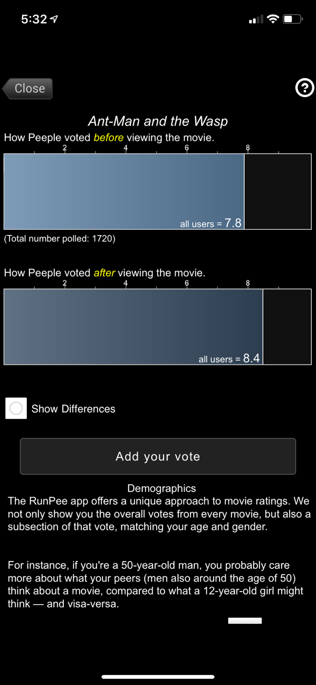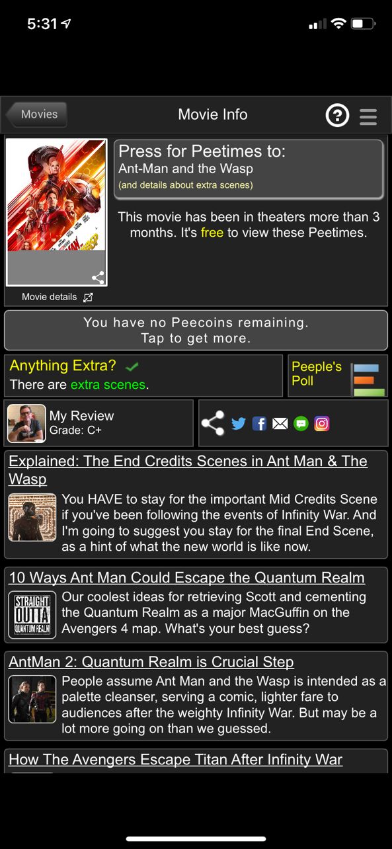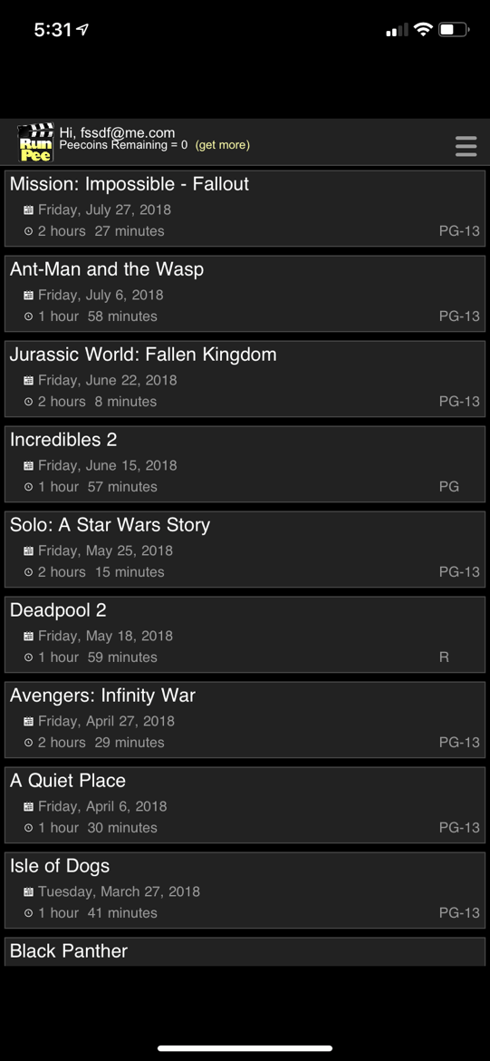Offers link to IMDB, does not actually have that information

Things to take from RunPee:

1. Simple user interface
2. Create an account feature
3. Poll options
4. If there are post movie scenes
5. Essential to have an attractive, seamless user interface
6. Need to figure out the best way to integrate cash flow streams
7. Centralize the best information usefully